**Name:Mudita Bhathar**

Questions:

1.Write a program to find out the prime numbers.

Code

t=int(input('total number:'))

list1=[]

list2=[]

for i in range(0,t):

n=int(input())

list1.append(n)

f=0

for i in range(2,n+1):

if n%i==0:

f=f+1

if f==1:

list2.append(n)

print('Numbers are:',list1)

print('Prime numbers are:',list2)

Input

total number:5

6

2

8

4

1

Output

Numbers are: [6, 2, 8, 4, 1]

Prime numbersa are: [2]

2.write a program to create the equation (a+b+c) *  (a-b-c) * ab + a^2 + b ^2 + (abc)^3.

Code

a=float(input())

b=float(input())

c=float(input())

def equation(a,b,c):

import math

d=((a+b+c)*(a-b-c)*a*b)+(a**2)+(b**2)+((a*b*c)**3)

return d

print(equation(a,b,c))

Input

2

1

3

Output

197.0

3. urlist = ['wood','knife','axe'] , mylist = ['tree', 'apple', 'mango', 'melon'] – combine two lists.

Code

urlist=['wood','knife','axe']

mylist=['tree','apple','mango','melon']

ourlist=urlist+mylist

print(ourlist)

Output

['wood', 'knife', 'axe', 'tree', 'apple', 'mango', 'melon']

In [14]:

4.write a program for natural number based on user input.

Code

totalnum=int(input('Total number of numbers:'))

ls=[]

for i in range(0,totalnum):

number=float(input())

if number%1==0:

ls.append(number)

print('Natural numbers from the following are:', ls)

Input

Total number of numbers:5

60.

68.2

9

8

23.13

Output

Natural numbers from the following are: [60.0, 9.0, 8.0]

In [18]:

5.write class and function for the equation sqrt(x1-x2) ^ 2 + sqrt( y1 – y2 ) ^2 using try except handling.

Code

class numbers:

def __init__(self,a,b,c,d):

self.x1=a

self.x2=b

self.y1=c

self.y2=d

def equation(self):

import math

try:

x1=float(self.x1)

x2=float(self.x2)

y1=float(self.y1)

y2=float(self.y2)

d=math.sqrt(((x1-x2)**2)+((y1-y2)**2))

return d

except:

print('Enter proper numeric values.')

Input 1

x=numbers(1,5,2,3)

x.equation()

Output

4.123105625617661

Input 2

w=numbers(1,'m',2,3)

w.equation()

Output

Enter proper numeric values.

6. Name  = “Guvi python”  - write a program to get “python” word from the string.

Code

Name="Guvi python"

d=Name.find('p')

print(Name[d::])

Output

python

7.Using class and function - Write a program for palindrome Ex. Madam.

Code

class program:

def __init__(self,a):

self.a=a

def palindrome(self):

if self.a==self.a[::-1]:

print(self.a,'is a palindrome.')

else:

print(self.a,'is not palindrome.')

Input 1

m=program('madam')

m.palindrome()

Output

madam is a palindrome.

Input 2

m=program('python')

m.palindrome()

Output

python is not palindrome.

8.using file handling – write a text file in ur system with “hello world”.

Code

file=open('Text2.txt','w') # already a text file with name Text2 is saved.

file.write('hello world')

file.close()

Output

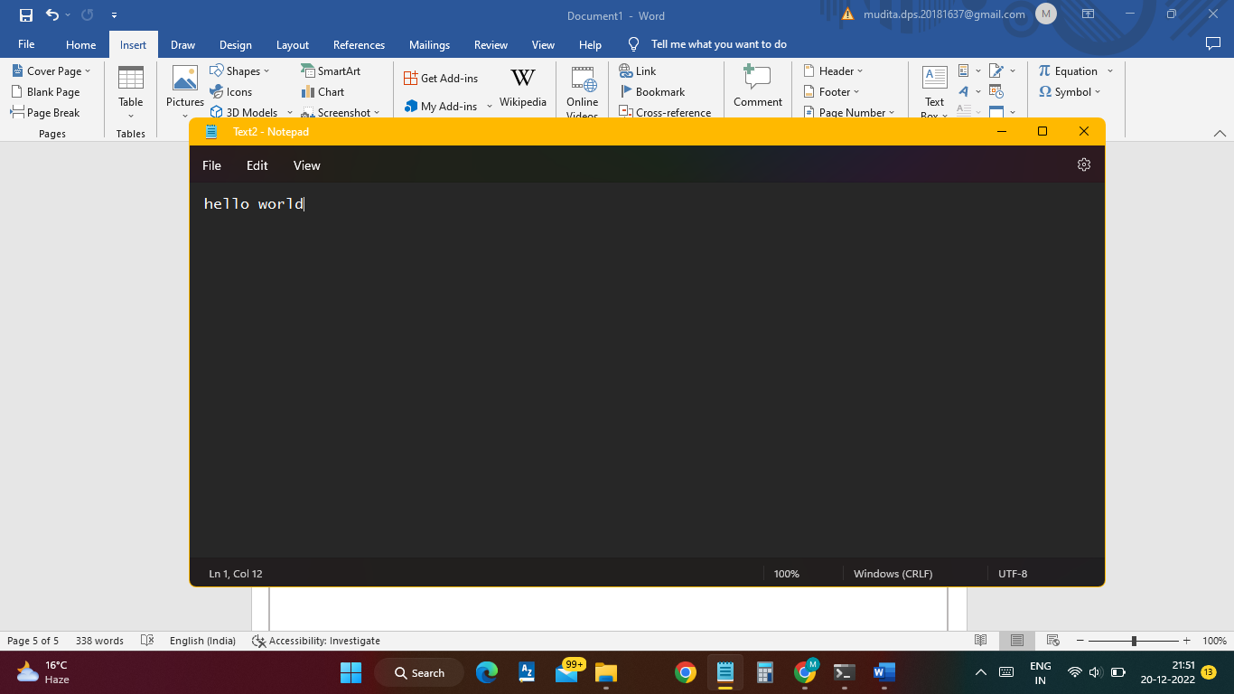

9.create option button using tkinter GUI in python.

Code

import tkinter as tk

r=tk.Tk()

r.title('The GUI in python')

button=tk.Button(r,text='Option',width=25,command=r.destroy)

button.pack()

r.mainloop()

Output

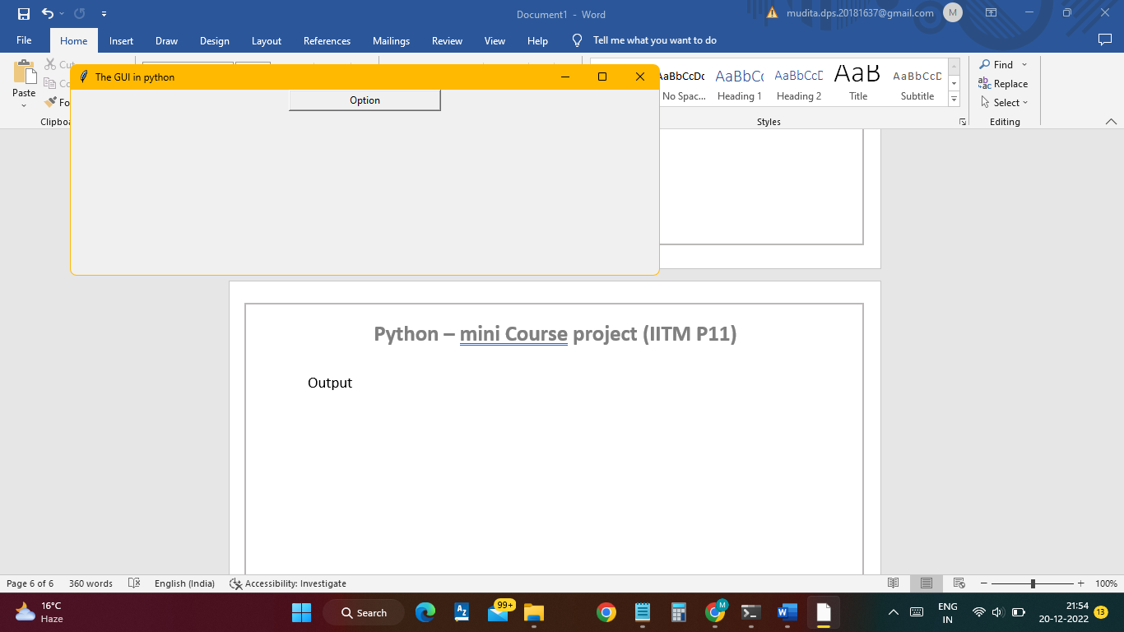

10.Keep only numbers from the following string x = “ 89e9jcd^o38829@3%3,/mkl$w1”.

Code

x = "89e9jcd^o38829@3%3,/mkl$w1"

import re

numbers=re.findall('\d+',x)

print(numbers)

Output

['89', '9', '38829', '3', '3', '1']